**Design Palette**

**Text:**

Font family - https://fonts.google.com/specimen/Arimo#standard-styles

Default text size – 16px

H1: Arimo

H2: Arimo

H3: Arimo

H4: Arimo

H5: Arimo

H6: Arimo

P: Arimo

A: Arimo

**Colors:**

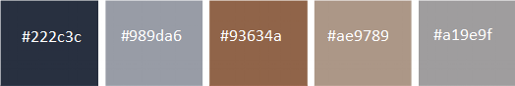

There might be also some other random colors used within small UI elements, but essentially all major UI elements are going to use the colors provided above.

UI elements:

Disclaimer: UI elements described below might differ compared to final website elements. We’re going to be adjusting design as we build the website and if there’s a discrepancy in overall design we might adjust few of the UI elements.

The **navbar** is going to look like this. There’s going to be our logo, few items such as Home, About us, etc.



Mobile version of the **navbar**. There’s going to be a logo on the left and a hamburger menu icon on the right that will include all the links to nav items.



**Content blocks** are going to look similar to this. They are going to have rounded borders and a slight box shadow. Some of the blocks will enlarge once hovered over.



The **footer** is going to look very similar to the navbar. It’s going to use the same color palette and items positioning.

To sum up the UI elements, our goal is to make all of them look minimalistic and clean. On top of writing the code for most of the elements ourselves, we also plan on using bootstrap 4.0 to source more advanced UI components and then customize them to fit our overall theme.